G4_Selenium Advance
How to Run Test Case

Members:
Huynh Thi Thu Huong – 2402
Nguyen Lieu Tu
Vu

I. How to get source code and setup VS? 1
II. Setup environment to run test case 7
III. Setup environment to run multiple browser 7
IV. Test Case Result Table 10

How to get source code and setup VS?
  - Step to get source code from Github
- Open https://github.com/login and login with valid account
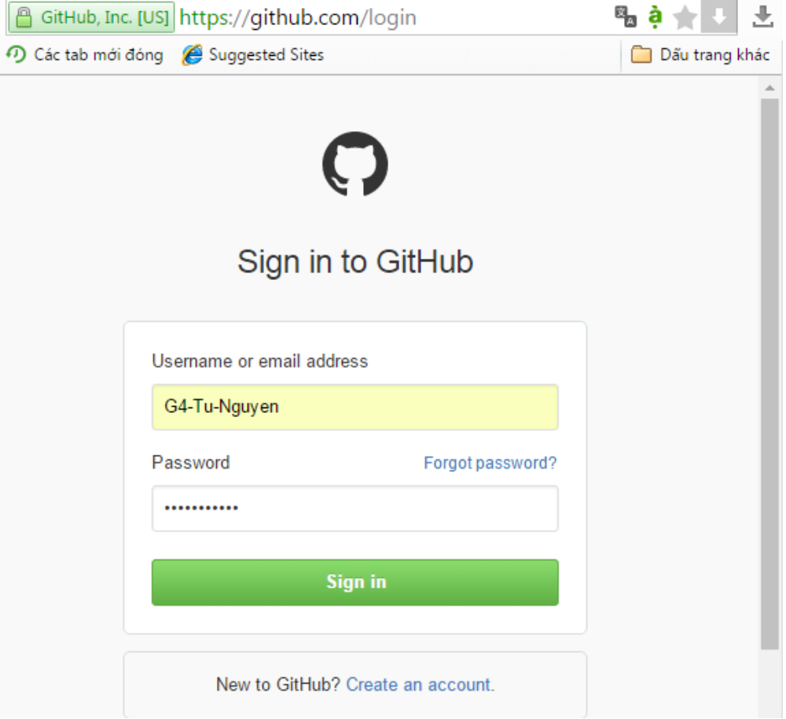
- Click on the repository that we created (ex: G4AdvSelenium)
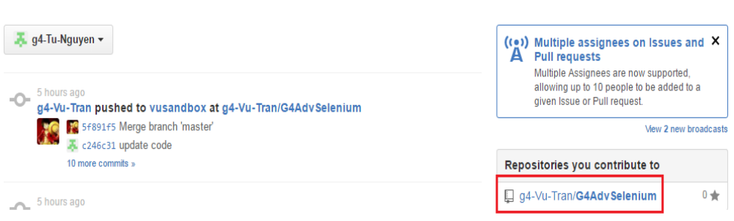
- Click on Clone or download button menu and copy the web URL

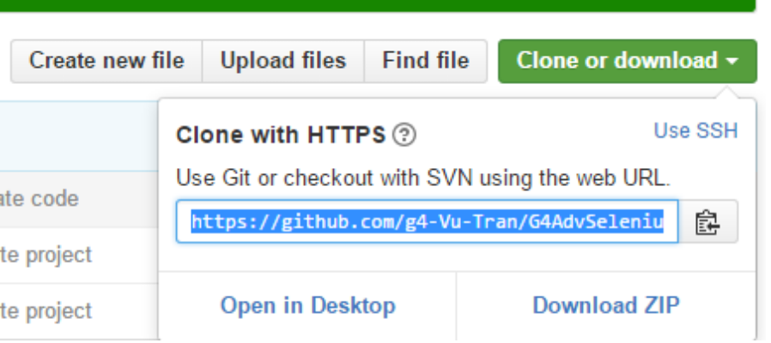
  - How to config Visual Studio with Github source code
- Open Visual Studio 2013

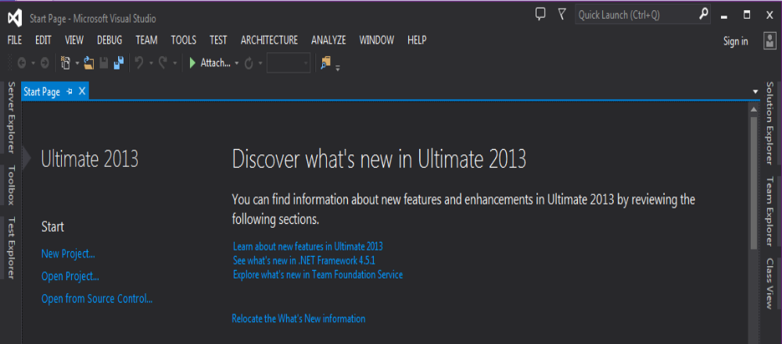
- Select View → Team Explorer

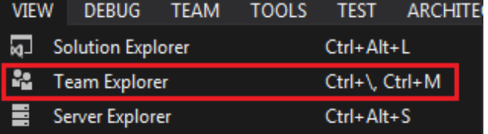
- In Team Explore panel, click Connect → Settings
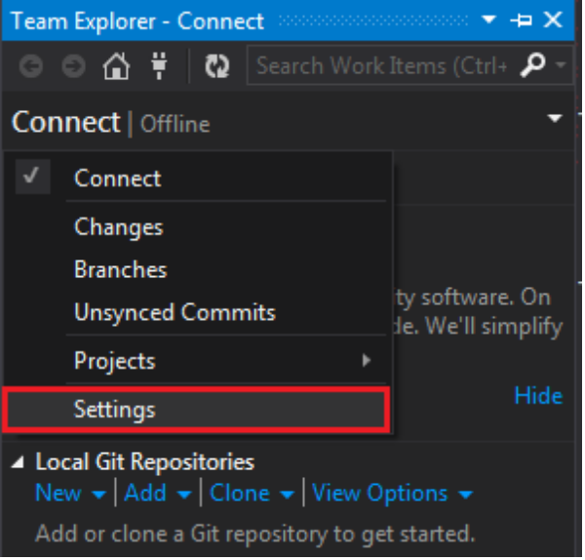
- Select Git Settings → Fulfil username and email address then click Update

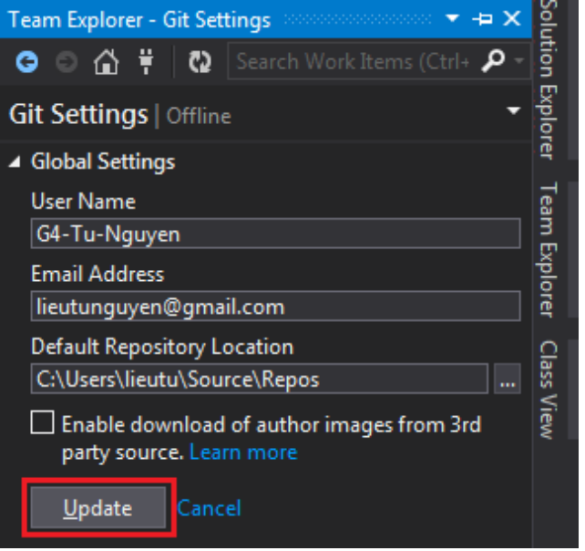
- On Connect window, under Local Git Repositories section, click Clone. Then enter Repo's URL that we copy from step 1, select the location where we want to save the repo and click Clone button to finish
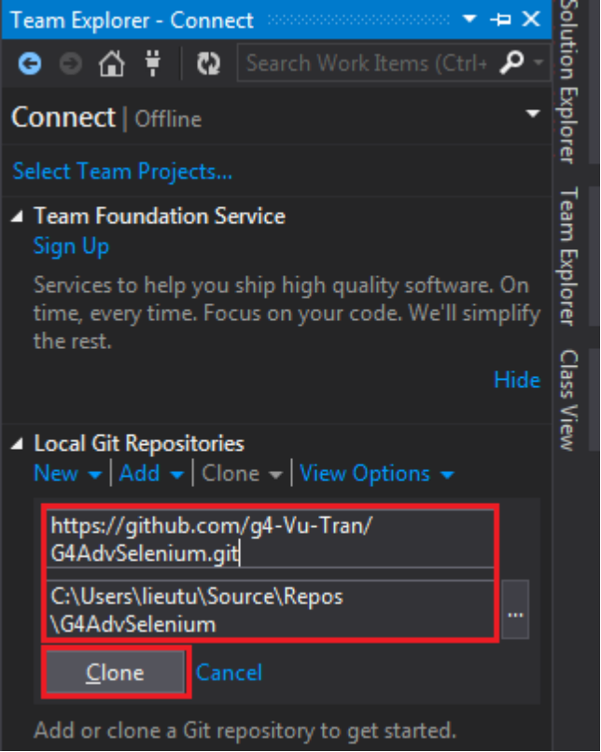
- After finishing clone repository, we double click on the repository that is displayed under Local Git Repositories section

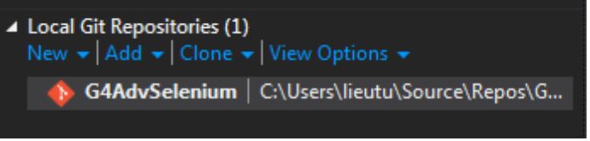
- Double click on the solution under Solutions section

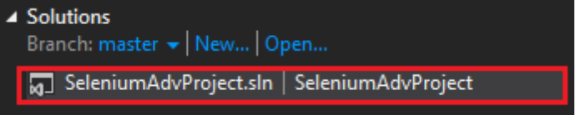
- Select BUILD → Build Solution to build all test cases in our solution

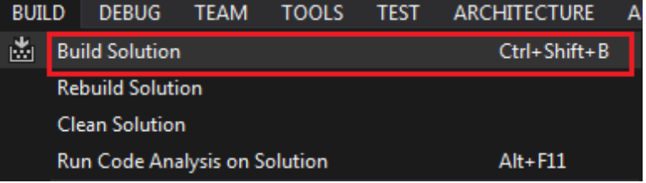
- Open Test Explorer panel
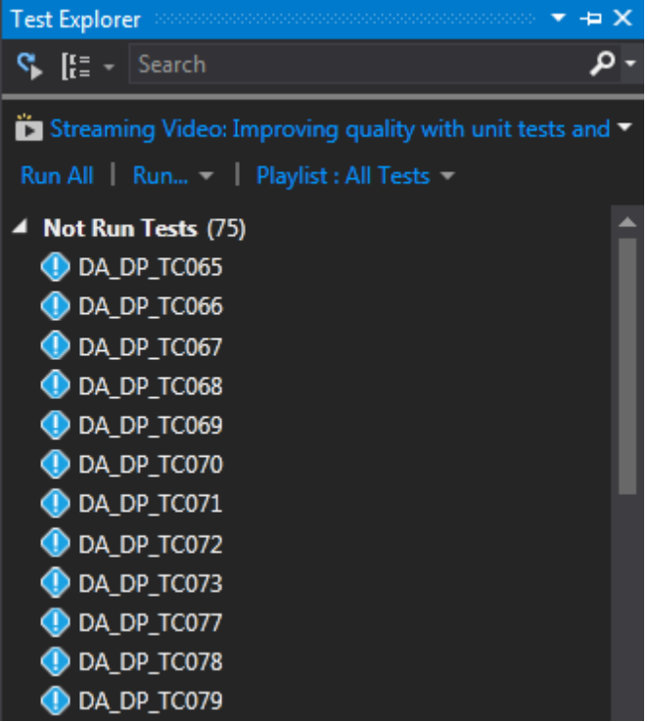
- Select any test case → Run Selected Tests (run 1 test case)

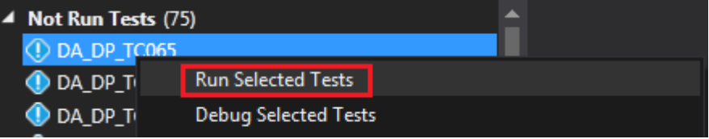
- Click Run All if we want to run all test cases in solution

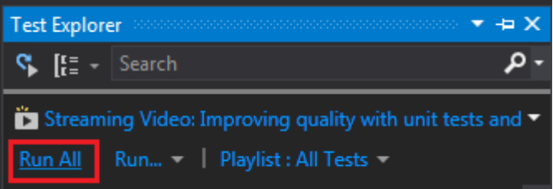
- Click Run → Run Not Run Tests (use to run all test cases that are not run)

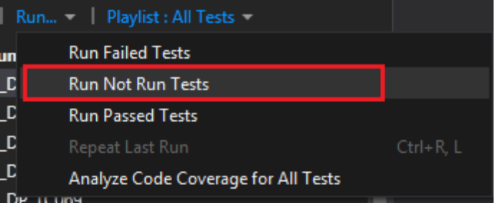

Setup environment to run test case
  - Browser:
  - Version: the latest version (44 or 45)
  - Turn off auto update version
    - Enter about:preferences in URL path
    - Select Advanced → Update
    - Set on for “Never check for updates (not recommend: security risk) radio button
  - Setup for Login Test Case:
    - Open TA Client and create account with username and password as below:
      - username1: test1
      - password1: !@#$%^&*()
      - username2: ADMIN
      - password2: blank (password is empty)
      - username3: admin
      - password3: blank (password is empty)
      - username4: @()
      - password4: blank (password is empty)
      - username5: vutran
      - password5:VUTRAN

Setup environment to run multiple browser
  - Setup Grid environment:
    - Download the Executable Jar File of Selenium Standalone Server at http://docs.seleniumhq.org/download

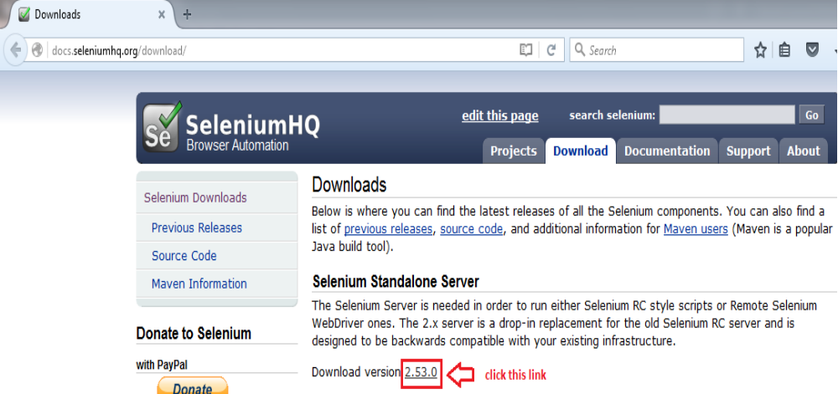
    - Open cmd window and start a Hub server using below syntax:
“java -jar <path_to_downloaded_executable_jar_file> -role hub -port <port_number>. This command shoud be ended up with a line tells you that Hub is up and running. You can open Hub console page at http://<machine_ip>:<hub_port>/grid/console after completed the command line
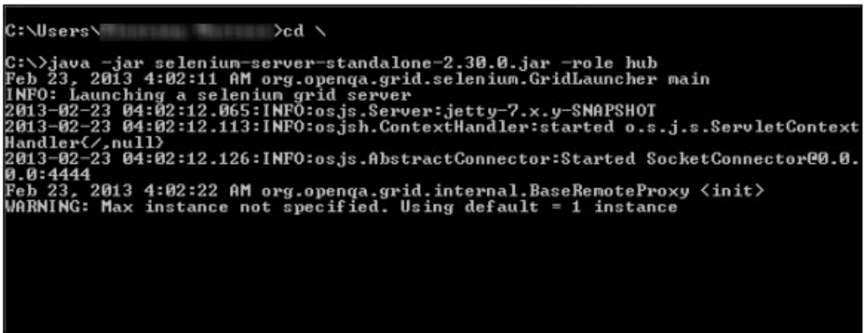
    - Open another cmd window and register a node with below syntax “java -jar <path_to_downloaded_executable_jar_file> -role node -hub http://<hub_ip>:<hub_port>/grid/register -browser browserName=<browser_name>,version=<browser_version>,maxInstances=5, platform=WINDOW”

  - Add test settings file to your current project
  - Right click on Solution → Add → New Item...
  - In the left menu, select Test Settings
  - Enter the name then click Add button

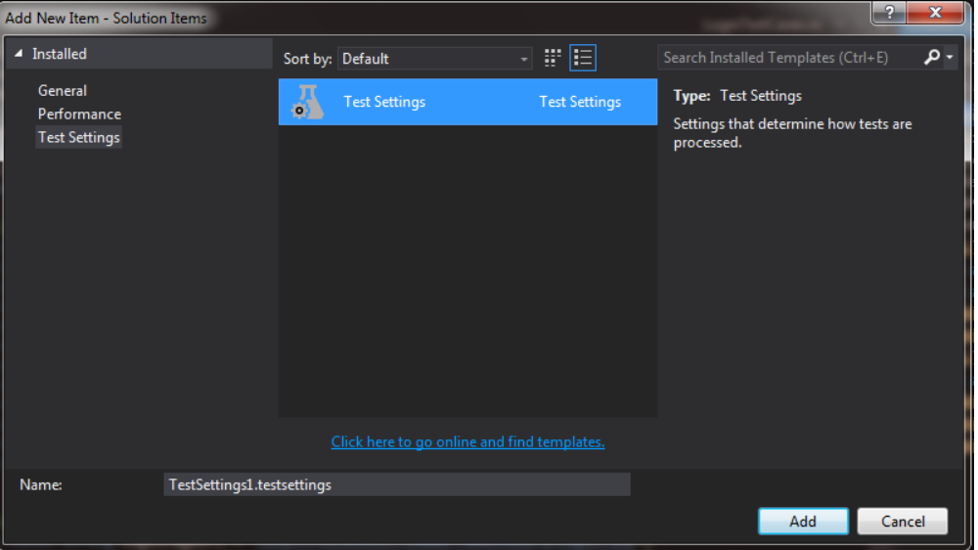
  - Right click on the newly created test settings file → Open With...
  - On Open With window, select XML (Text) Editor, then click OK button
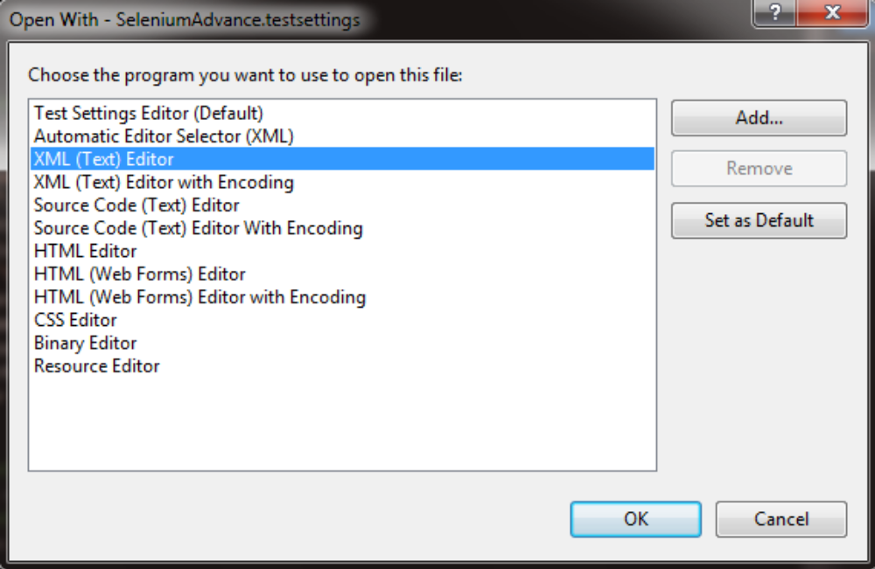
  - Add the execution settings as picture below

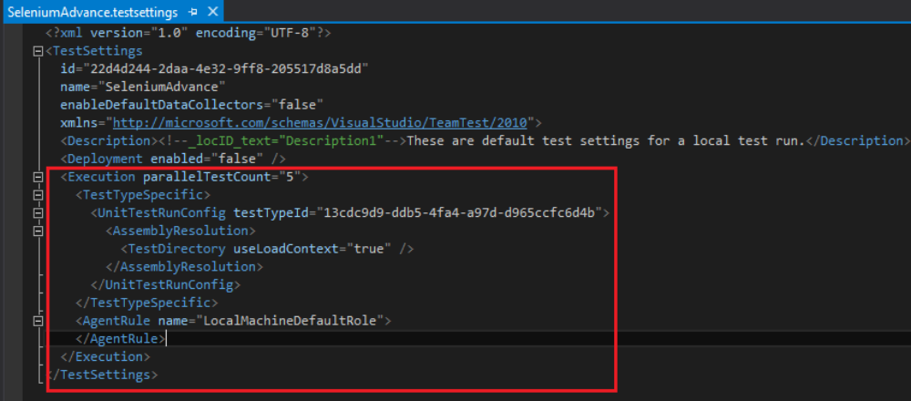

  - From menu bar, select TEST → Test Settings → Select Test Settings File
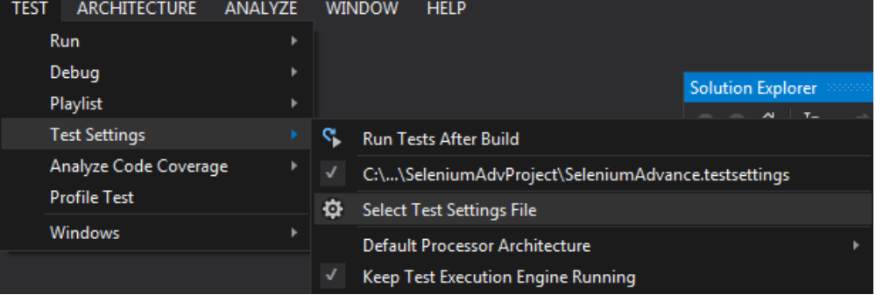
  - Choose the newly created test settings file, and then click on Open button
  - Now, you will need to use the RemoveWebDriver and the DesiredCapabilities object to define which browser, platform, version you wish to use.

Test Case Result Table

Test Case Name | Automation Result | Note

